**Decision making tree algorithm:**

**Classification of Decision Tree:**

A decision tree is a non-parametric supervised learning algorithm, which is utilized for both classification and regression tasks. It has a hierarchical, tree structure, which consists of a root node, branches, internal nodes and leaf nodes.

* **Root Node** is the starting point that represents the entire dataset.
* **Branches**: These are the lines that connect nodes. It shows the flow from one decision to another.
* **Internal Nodes**are Points where decisions are made based on the input features.
* **Leaf Nodes**: These are the terminal nodes at the end of branches that represent final outcomes or predictions

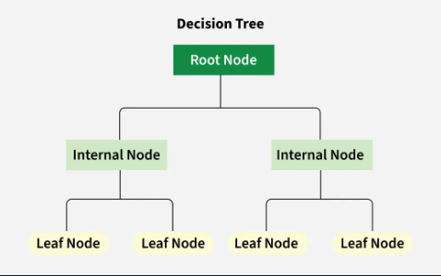

We have mainly two types of decision tree based on the nature of the target variable:**classification trees and regression trees.**

* **Classification trees:**They are designed to predict categorical outcomes means they classify data into different classes. They can determine whether an email is “spam” or “not spam” based on various features of the email.
* **Regression trees :** These are used when the target variable is continuous It predict numerical values rather than categories. For example a regression tree can estimate the price of a house based on its size, location, and other features.

**How Decision Trees Work?**

A decision tree works by asking a **main question** at the start, called the **root node**. This question helps guide the decision-making process.

For example, if you are choosing a laptop, the first question might be **"Is my budget over $1000?"** If **"Yes"**, you look at high-end models; if **"No"**, you check budget-friendly options.

Next, more **yes/no questions** help narrow your choice. You might ask **"Do I need a gaming laptop?"** or **"Do I want long battery life?"** Each answer leads to a different option.

This process continues until you reach a **final decision**, like **"Buy Laptop A"** or **"Buy Laptop B"**, based on your needs.

**Advantages of Decision Trees**

* **Simplicity and Interpretability:** Decision trees are straightforward and easy to understand. You can visualize them like a flowchart which makes it simple to see how decisions are made**.**
* **Versatility:** It means they can be used for different types of tasks can work well for both classification and regression
* **No Need for Feature Scaling:** They don’t require you to normalize or scale your data.
* **Handles Non-linear Relationships:** It is capable of capturing non-linear relationships between features and target variables**.**

**Disadvantages of Decision Trees**

* **Overfitting:** Overfitting occurs when a decision tree captures noise and details in the training data and it perform poorly on new data.
* **Instability**: instability means that the model can be unreliable slight variations in input can lead to significant differences in predictions**.**
* **Bias towards Features with More Levels:** Decision trees can become biased towards features with many categories focusing too much on them during decision-making. This can cause the model to miss out other important features led to less accurate predictions .

**Applications of Decision Trees**

* **Loan Approval in Banking:** A bank needs to decide whether to approve a loan application based on customer profiles**.**
  + Input features include income, credit score, employment status, and loan history.
  + The decision tree predicts loan approval or rejection, helping the bank make quick and reliable decisions**.**
* **Medical Diagnosis:**A healthcare provider wants to predict whether a patient has diabetes based on clinical test results**.**
  + Features like glucose levels, BMI, and blood pressure are used to make a decision tree.
  + Tree classifies patients into diabetic or non-diabetic, assisting doctors in diagnosis.
* **Predicting Exam Results in Education :** School wants to predict whether a student will pass or fail based on study habits**.**
  + Data includes attendance, time spent studying, and previous grades.
  + The decision tree identifies at-risk students, allowing teachers to provide additional support**.**

A decision tree can also be used to help build automated predictive models, which have applications in machine learning, data mining, and statistics.**:**